**Banner Image:**

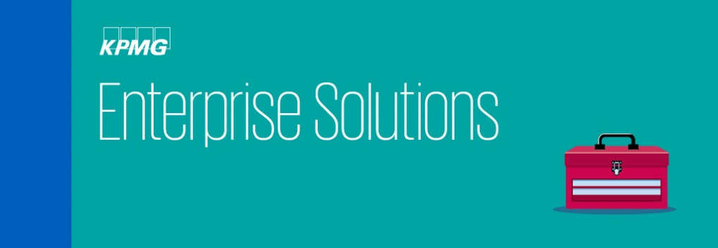

**Content:**

**Our Enterprise Solutions professionals help clients across the enterprise systems life cycle, from evaluation through implementation and ongoing upgrades and improvement. Our team will help clients determine whether cloud solutions provide a viable alternative to enterprise applications. If so, we help clients think through the integration to existing systems.**

Many companies are operating multiple, dated legacy systems while facing vendor-mandated upgrades or ERP consolidations. Some want to explore new products and ways to engage with customers. KPMG's technology enablement services help clients across the enterprise systems lifecycle – from evaluation through implementation and ongoing upgrades and improvement.

We help clients investigate initiatives such as Software-as-a-Service (SaaS) and cloud as well as business intelligence and finance transformation to create competitive advantage. With leading practices, we also help them improve IT total-cost-of-ownership and create better alignment with business processes. Further, we help them reduce compliance costs through automated controls and improved access and business process monitoring.

Importantly, we help clients evaluate and develop their most effective internal operating model and manage the organizational change required for successful transformation projects.

**Enterprise Systems Implementations: Oracle**

KPMG takes a business-led approach to technology implementations. This transformative approach enables companies to align their business strategy with the Oracle enabling technology, and realize the full potential to outperform their peers. Our advisors have years of experience helping clients maximize the return on their historic and future Oracle technology investments. In most implementations, organizations focus on the system implementation and overlook the business transformation—KPMG does both.

As an Oracle Global Cloud Elite partner, our team of business and technical specialists work with clients as a "business integrator" and not merely as a systems integrator. Our multi-disciplinary teams provide deep technology, industry and operations experience—all backed by our recognized tax, regulatory compliance and financial heritage.

Our Oracle practitioners work with clients around the globe to meet the business transformation and system implementation needs for all-sized enterprises across the improvement lifecycle - from strategy through ongoing management.

**We focus on these Oracle enabled solutions:**

* KPMG Powered Enterprise
* Cloud EPM & Finance
* Cloud HCM
* Identity & Access Management
* Governance Risk & Compliance
* Business Intelligence
* Oracle Financial Services Analytical Applications (OFSAA)
* Health and Human Services



**Enterprise Systems Implementations: Workday**

Drawing on KPMG LLP’s deep domain experience in the areas of finance and human capital management, we help clients reach their business objectives and transform their businesses with Workday.

Our clients are enabled to implement Workday solutions rapidly so they can quickly realize measurable ROI. We also help them lay a foundation for long-term strategic alignment with organizational and IT goals and consider broader objectives such as:

* Global service delivery models
* Opportunities to create more agile processes to quickly react to business change
* The effects implementing new SaaS-based solutions have on people
* Better ways to provide reporting and analytics at an enterprise level
* Addressing risk and controls

*We focus on these Workday solution areas:*

**Financial Management**

Finance Transformation enabled by Workday moves beyond simply replacing current GL platforms and addresses the key areas of people and processes to set the foundation for continuous improvement leveraging the capabilities of the Workday platform. 

**Human Capital Management**

Human Capital Management Solutions enabled by Workday help our clients to rapidly plan, design and deploy Workday HCM solutions to leverage their number one corporate asset — people — to accelerate business innovation and competitive differentiation. 

**Integrated Payroll**

KPMG brings together the key components necessary to leverage Workday Payroll and address global payroll issues. KPMG’s HR organization and process capabilities coupled with global shared services and global tax capabilities enables us to pull all of the diverse pieces together that are required for an integrated payroll solution. 

**Optimization and Support Services**

SaaS-based solutions require a proactive and ongoing effort to optimize system configuration, deploy new features, and achieve compliance with internal governance and control policies. KPMG’s services go beyond simply providing capacity and leverage our experience across Financials and HCM to provide a framework for continuous improvement.